Von-Neumann Model

* Objectives
  + show understanding of the basic Von Neumann model（冯·诺依曼模型） for a computer system and the stored program（存储程序） concept
  + show understanding of the roles carried out（实施） by registers（寄存器）, including the difference between general purpose and special purpose registers: Program Counter, Memory Data Register（内存数据寄存器）, Memory Address Register, Index Register（索引寄存器）, Current Instruction Register（现行指令寄存器） and Status Register（状态寄存器）
  + show understanding of the roles carried out by the Arithmetic and Logic Unit (ALU，算术与逻辑部件), Control Unit and system clock
* Von-Neumann Model
  + <https://www.bilibili.com/video/av46133070?p=6>

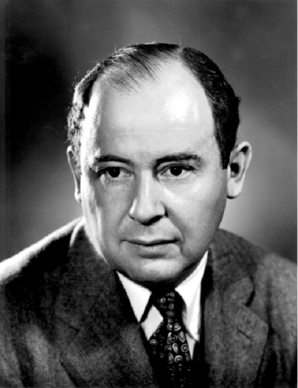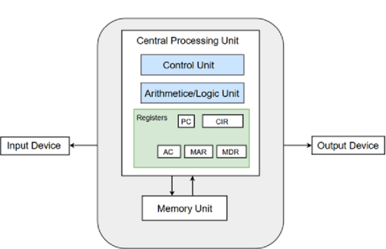

* + The model has the following basic features:
    - There is a **processor**, a central processing unit.
    - The processor has direct access to a **memory**.
    - The memory contains a '**stored program**' and the data required by the program.
    - The stored program consists of individual **instructions**.
    - The processor executes instructions sequentially.
* CPU
  + Arithmetic Logic Unit (ALU)
    - performs calculations on data
      * arithmetic operations
      * logical operations
      * comparisons
    - Accumulator(ACC)
      * intermediate arithmetic and logic results are stored in this register
  + Control Unit (CU)
    - The Control Unit of a computer system controls the operations of components like ALU, memory and input/output devices.
    - A vital part of the control unit is a **clock** which is used to synchronise processes.
      * The CPU have a frequency for its **clock cycle**, which is usually referred to as the **clock speed**. The frequency defines the minimum period of time that separates successive 依次的 activities within the system.
  + Registers: a component inside a CPU for storing temporary information, it usually consist of a small amount of fast storage.
    - There is only one general-purpose register, we called it accumulator. There are some special-purpose register such as PC, CIR, MAR,MDR,IX,SR
    - Memory Address Register (MAR)
      * MAR holds the memory address of data that needs to be accessed. When reading from memory, data addressed by MAR is fed into the MDR (memory data register) and then used by the CPU. When writing to memory, the CPU writes data from MDR to the memory location whose address is stored in MAR. AR保留了需要访问的数据的存储位置。从存储器读取数据时，MAR寻址的数据将被馈送到MDR（存储器数据寄存器）中，然后由CPU使用。写入内存时，CPU将数据从MDR写入地址位于MAR中的内存位置。
    - Memory Data Register (MDR)
      * When a data or program instruction is to be read from or written to memory, its value is temporarily stored in the memory data register (MDR) to speed up the computer.当要从内存中读或写数据或程序指令，其值将临时存储在内存数据寄存器(MDR)中以加快计算机的运行速度。
    - Current Instruction Register (CIR)
      * CIR is a register that stores the instructions currently waiting to be executed by CPU.
    - Program Counter (PC), Instruction address register (IAR)
      * If a program is thought of as a sequence of instructions stored in a consecutive 连贯的 block of memory cells, the processor must always be clear about the address at which the next program instruction to be executed is stored.
      * This register contains the address of the next instruction to be executed.
    - Status Register(SR)
      * Each bit of the status register indicates whether a different event has occurred.
      * An individual bit position will flag outcomes such as the following for arithmetic operations:
        + carry: there was a value to carry
        + zero: the result was zero.
        + negative: the result was negative.
        + overflow: the result ( on a two's complement number) is out of range.
    - Index Register (**IX**)
      * Stores a value only used for indexed addressing mode
      * The actual address of the variable = variable initial address + index register value
    - Accumulator(ACC)
      * intermediate arithmetic and logic results are stored in this register
* Buses
  + Von-Neumann Architecture comprised of three major bus systems for data transfer.
  + Address Bus
    - Address Bus carries the address of data (but not the data) between the processor and the memory.
  + Data Bus
    - Data Bus carries data between the processor, the memory unit and the input/output devices.
  + Control Bus
    - Control Bus carries signals/commands from the CPU.
* <https://www.bilibili.com/video/av46133070?p=7>